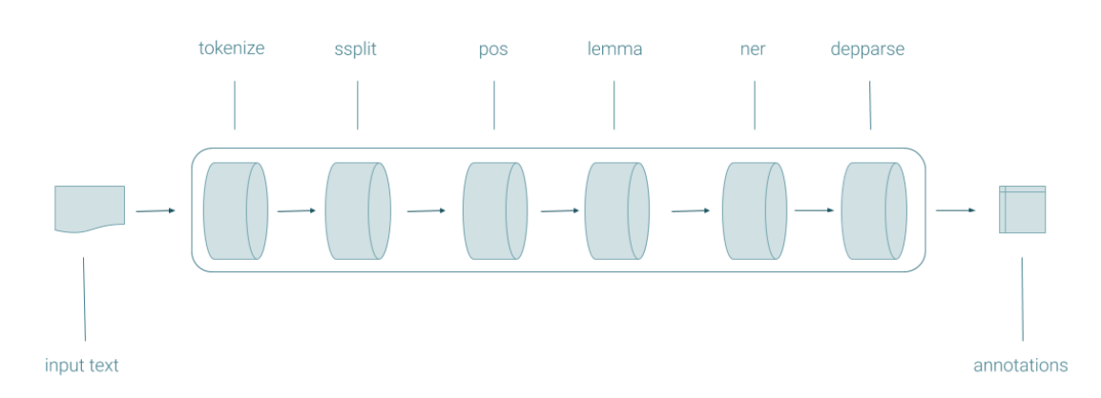
How a text must be treated (from core NLP)

Process that we have to do when we approach a text:
Tokenize: divide the text input into a sequence of tokens, i.e. words. All words are demarcated by space, separating punctuation marks (look at https://dh.fbk.eu/tint-demo/).
- Split: sentence splitting (in some languages sentences can be only a word)
- Pos: part of speech tagging, give a category to the words that we have identify (Noun, Adjective, Verb…) 🡪 what we will do in this part

PART OF THE SPEECH CLASS
Open class words:
- Noun 🡪 NOUN
- Proper noun 🡪 PROPN
- Adjective 🡪 ADJ
- Verb 🡪 VERB
- Adverb 🡪 ADV
- Interjection 🡪 INTJ

Nouns
Morphologically they have endings for gender and number -a, -e, -o, -i (in Italian and other languages, but not in Japanese, in English only number).
Semantically denote objects (but there are also abstract nouns).
Syntactically they can act as the subject of the verb or argument of verb, and in several languages they are preceded by determiners (articles, demonstrative) or classifiers (like in Mandarin).

Verbs
Morphologically they have various endings indicating the modality, tense, aspect.
Semantically describe actions (but there are also verbs describing states, lying).
Syntactically agree with the subject, have complements.

Nouns and Verbs are present in all languages. There are expections to previous definitions:
- Abstract nouns: beauty, song
- The sentences can be the subject of the verb: [The fact that Gianni and Maria left] has astonished Luca
What happens if you put these nouns in the plural?
- Furniture 🡪 Mobilia
- Rice 🡪 Riso
- Milk 🡪 Latte
- Wine 🡪 Vino

RECUPERARE LEZIONE 14/03 (ultimi 15 minuti)
Closed class include:
- Adposition
- Auxilieries
- Conjunction
- Determiner
- Number
- Particle
- Pronoun
- Subordinating Conjunction

Auxilieries: is a function that …
….

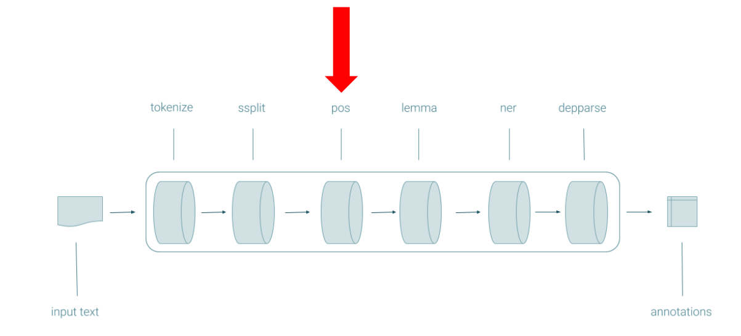

POS
- Lemma
- Ner 🡪 named entity recognition, identify which words are nominal entities within the text, for example usually the categories you use are LOCATION, ORGANIZATION, PERSON
- Depparse 🡪 Dependency parsing, identify the syntactic dependencies of the input, example of a nominal subject relationship: https://universaldependencies.org/it/dep/nsubj.html

What we know until now:
- Part of the speech
- Something about how to deal with a text to process

